1. Read the question and the student’s answer carefully.
2. Use the mark scheme to award the student a number of marks and annotate their answer with suggestions to improve.
Stretch: Rewrite the answer to show how it should be done!

Question:
Propane is an alkane.
Two equations for the combustion of propane are shown below.

C₃H₈ + 5 O₂ 4 H₂O + 3 CO₂
C₃H₈ + 3 O₂ 4 H₂O + 2 CO + C

- Explain why there are different products formed in these reactions. (2)
- The products CO and CO₂ can both have negative consequences. Explain how. (4)

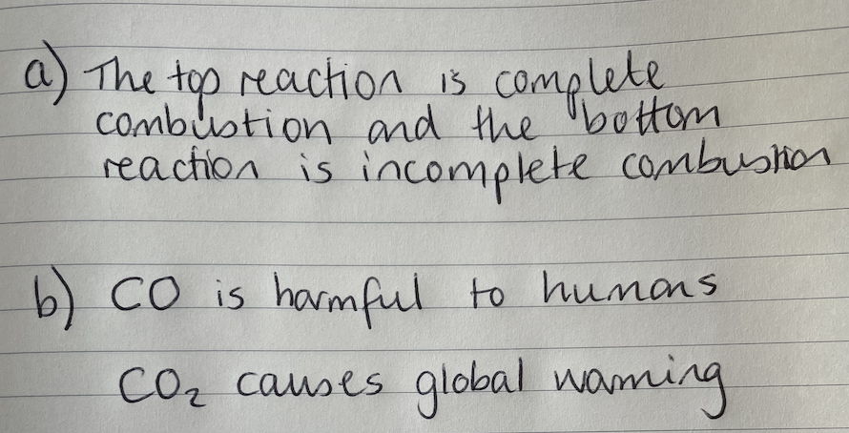
Student answer:

Marks awarded= _______
Mark scheme:

Point | Mark
Complete vs incomplete combustion | 1
Not enough oxygen/air is available (in incomplete combustion) | 1

Point | Mark
CO (carbon monoxide) is toxic/poisonous | 1
CO stops oxygen being carried around the body | 1
Carbon dioxide is a greenhouse gas | 1
Increasing greenhouse gas emissions are contributing to global warming | 1

